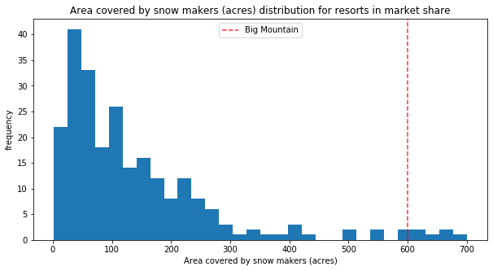My model has found that Big Mountain Resort is currently under-charging for Adult Weekend ticket prices. Based on the available data, Big Mountain should consider increasing ticket prices from the current $81.00 to $94.22 in order to capture the entire value of its unique features. The current strategy of positioning Big Mountain as a premium level resort is indeed supported by the features offered.

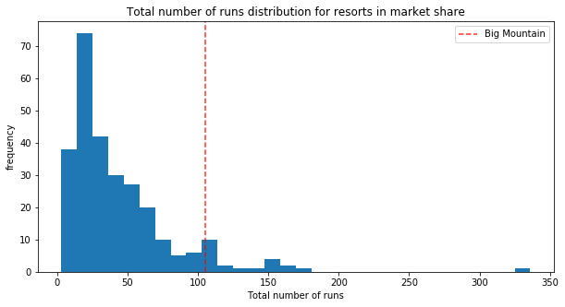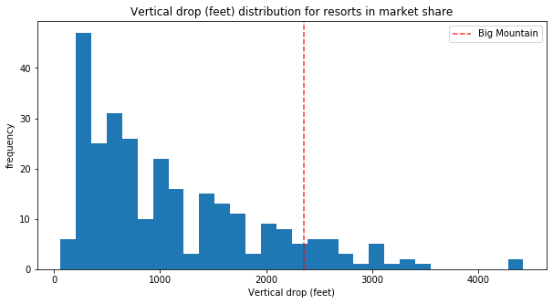

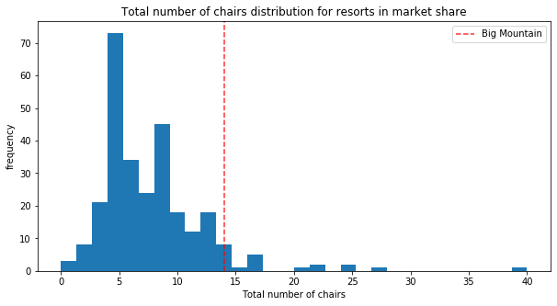

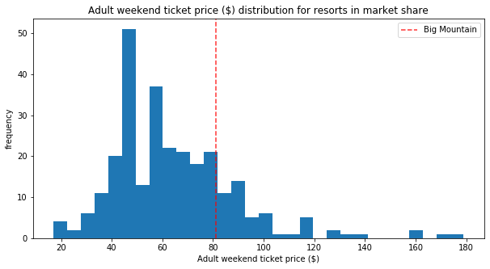As seen in the figures above, Big Mountain ranks among the top resorts in the country in the most important features considered for determining ticket price. However, if we look at the distribution of Adult Weekend prices nationwide, Big Mountain falls much closer to the national average ticket price.

In addition to evaluating the resort’s ticket price selection, I reviewed several scenarios suggested to either raise revenue or cut costs. Scenario 2 – which includes adding an additional run, an additional chairlift, and an additional 150 ft. of vertical drop – would support increasing the ticket price by an additional $8.46 and would increase revenue for the season by $14,811,594.00. This additional revenue would more than cover the cost of the most recent chairlift added ($1,540,000) and the additional chairlift needed to reach the new summit. Scenario 1 would drastically reduce the ticket price and have a significant impact on revenue, as seen below.

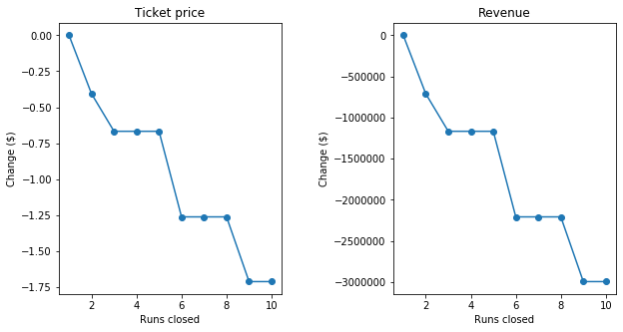

Neither Scenario 3 nor 4 would support an additional increase in ticket price, despite the costs of implementation. With this knowledge, I would recommend that management at least consider an increase to the ticket price charged. If they wish to pursue any of the proposed scenarios, the model predicts that Scenario 2 would be the sole proposal to increase the value of the park.